

**UNIVERSITI KUALA LUMPUR CITY CAMPUS**

**MALAYSIAN INSTITUTE OF INFORMATION TECHNOLOGY**

|  |  |
| --- | --- |
| Name of Course | **SOFTWARE ENGINEERING** |
| Course Code | **ITD31403** |
| Lecturers | **Muhammad Rizal** |
| Semester / Year | **Oct 2024** |
| Week | **7** |
| Date | **27Nov2024** |

|  |  |
| --- | --- |
| Assessment | **Lab Activity 7 : Introduction to Version Control with Git and GitHub** |
| Submission | **No submission** |

**Objective:** Familiarize students with DevOps concepts, GitHub setup, and version control basics.

* Introduce DevOps principles and GitHub as a version control system.
* Enable students to set up their GitHub accounts and repositories.
* Basic commit and push basic code.

**Tools/Software Required:**

* Computer with internet access
* Git (download from git-scm.com)
* Visual Studio Code (VS Code)
* GitHub account

**Lab Steps**

**Step 1: Introduction to DevOps**

1. What is DevOps?

* DevOps is a set of practices that combines software development (Dev) and IT operations (Ops) to shorten the development lifecycle.

1. Key Benefits of DevOps:

* Faster delivery, improved collaboration, and automation.

1. How GitHub supports DevOps:

* Version control and collaboration for CI/CD pipelines.

**Step 2: GitHub Setup**

1. **Create a GitHub Account:**

* Go to GitHub and sign up for a free account.
* Verify the email address.

1. **Install Git on Your Computer:**

* Download and install Git from git-scm.com.
* Configure Git:

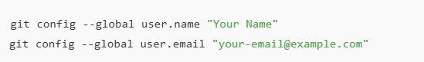

1. **Install VS Code:**
   * Download and install from code.visualstudio.com.

**Step 3: Set Up a Repository**

1. Open GitHub and create a new public repository:

* Repository name: software-engineering-lab1
* Description: "Lab 1 - Introduction to GitHub and Version Control"

1. Clone the repository locally :

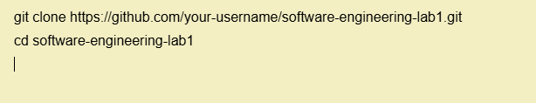

**Step 4: Create a Basic HTML File**

1. Open the repository folder in VS Code.
2. Create a new file named index.html with the following content:  
     
   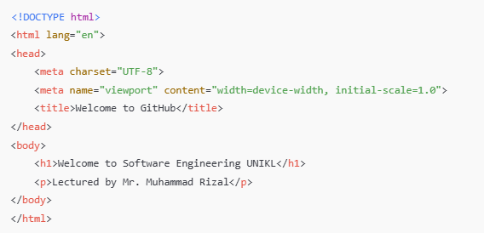
3. Save the file

**Step 5: Commit and Push Changes**

1. Use Git to track changes:

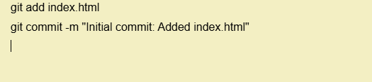

1. Push changes to GitHub

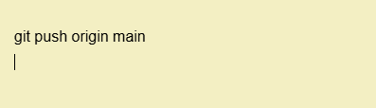

1. Verify the file appears in the GitHub repository online

**Key Learning Points**

* Understanding the basics of DevOps and GitHub.
* Setting up a GitHub repository and using Git commands.
* Making and pushing changes to a remote repository.